**Skillgram**

### Rahul Ganpatrao Sonkamble

Computer Engineering, MIT Art, Design and Technology University, Pune (412201), Maharashtra, India,

(+91) 7387427827

[rahulgsonkamble@gmail.com](mailto:rahulgsonkamble@gmail.com)

Chaitanya Yadwad

Computer Engineering, MIT Art, Design and Technology University, Pune (412201), Maharashtra, India,

(+91) 8999246722

[chaitanyayadwad8@gmail.com](mailto:chaitanyayadwad8@gmail.com)

### Jayditya Ashwin Nandkar

Computer Engineering, MIT Art, Design and Technology University, Pune (412201), Maharashtra, India,

(+91) 9285533055

[jayditya2082@gmail.com](mailto:jayditya2082@gmail.com)

Swapnil Chaudhari

Computer Engineering, MIT Art, Design and Technology University, Pune (412201), Maharashtra, India,

(+91) 9168464859

[swapnil79chaudhari@gmail.com](mailto:swapnil79chaudhari@gmail.com)

Atharva Zanwar

Computer Engineering, MIT Art, Design and Technology University, Pune (412201), Maharashtra, India,

(+91) 7887448502

[athzanwar@gmail.com](mailto:athzanwar@gmail.com)

**ABSTRACT**

This study is an attempt to explore the use and benefits of social media and mobile devices in transferring resources and interacting with academics in higher education institutions across the boundary wall. This empirical study is based on the survey of 360 students from a university in eastern India that captures students' perceptions of social media and mobile devices through collaborative learning, interactivity with peers and teachers, and their significant impact on students' academic performance. A structural equation modelling approach based on latent variances was used to measure and validate the instruments. The study found that online social media used for collaborative learning had a significant impact on interactivity with peers, teachers, and online knowledge sharing behavior.

# INTRODUCTION

Interactivity with teachers, peers, and online knowledge sharing behaviours have a significant impact on student engagement, which consequently affects student academic achievement. Based on this finding, it would be valuable to mention that using online social media for collaborative learning facilitates students to be more creative, dynamic, and research-oriented. It is a pure knowledge domain.

In today's fast-paced and dynamic world, the ability to learn new skills and keep up with the latest trends is more important than ever. But the traditional method of learning new skills is limited. Most people want to interact with like-minded people who share the same interest in learning a particular topic or skill, and this is where the most important factor comes into play: "experience." People like students, freelancers or new professors want to get information from experienced learners, so they share their general learning experiences and problems they faced while learning a skill and give tips and tricks to other people. So this is where social media plays a very important role. A social networking app that allows users to share and learn together has the potential to provide a convenient and cost-effective way for individuals to develop new skills and connect with like-minded individuals. By leveraging the power of technology, this type of app can facilitate collaborative learning, connect users to a global community of learners, and provide personalised learning experiences

In this introduction, we will explore the benefits of a social networking app for sharing and collaborative learning, its potential impact on society, and how it can help individuals achieve their learning goals.

A social networking app that allows users to find each other based on a shared interest in specific skills, such as musical instruments or a particular programming language. It was built in Angular 2 using a Firebase database.

Its features:

- User authentication with Firebase

- The ability to search for users based on a skill or their location

- A many-to-many relationship between users and skills

- User profile page to display each user's username, email, profession, photo, and skills.

.

# OBJECTIVES

The use of social media and mobile devices brings both benefits and challenges, with the benefits seen primarily in terms of accessing course content, video clips, transferring class notes, etc.

The purpose of this research project was to examine how the integration and use of mobile devices affects learning and teaching activities in higher education institutions when it comes to sharing resource materials, interacting with colleagues, and student academic performance. The overall goal of this research was to capture the in-depth perspectives of students' perceptions of mobile devices and social media in learning and teaching activities. It provides us with students' opinions of social media and mobile devices when integrated into higher education to access and interact with peers.

1. Facilitate skill sharing: The app should make it easy for users to share their skills and knowledge with others. This could include creating a user-friendly interface that allows users to upload tutorials, create online courses, or share tips and advice.

2. Fostering a sense of community: the app should create a welcoming and supportive environment where users feel comfortable sharing their skills and learning from others. This could include features such as discussion forums, social media-style profiles, or group chat rooms.

3. Encouraging collaboration: the app should encourage users to work together to develop their skills. This could be done by creating tools that allow users to connect with others who share similar interests or features that allow users to work together on projects or tasks.

4. Provide personalized learning opportunities: The app should provide users with personalized learning recommendations based on their interests, skills, and learning style. This could include using machine learning algorithms to suggest courses, articles, or videos that match the user's preferences.

5. Measuring progress and performance: The app should provide users with tools to track their progress and celebrate their success in learning new skills.

# FLOWCHART

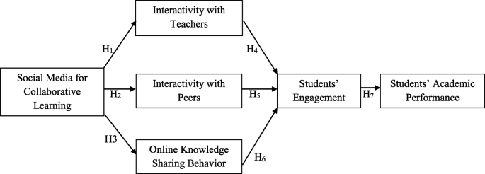

# METHODOLOGY

Concept:

The concept focuses on creating a community of learners who can help each other acquire new skills, knowledge, and experiences. The app aims to provide a platform where users can connect with each other, share their skills and knowledge, and work together on projects and tasks.

Method:

The following are some methods that could be used to develop a social networking app that helps users share their skills and learn together:

1. Conduct Research: Before developing the web app, it is important to conduct research to identify the target audience, their needs and problems, and the existing solutions in the market. This can be done through surveys, interviews and market analysis.

2. Define the features: Based on the research, define the key features that the app should have. These could include a profile system, discussion forums, messaging, course creation, collaboration tools, and personalized learning recommendations.

3. Design the user interface: once the features are defined, design the user interface to ensure it is easy to use, visually appealing, and functional. The interface design should focus on usability.

4. Develop the app: use a programming language or app development platform to build the app. For this, you can hire developers or outsource the work to an external development company.

5. Test the app: before you launch the app, it is important to test it to ensure that it is bug-free and works as intended. This can be done through alpha and beta testing as well as user feedback.

Technological innovation and increased use of the Internet for e-learning by college students have led to revolutionary changes in communication behavior. A report on 3000 college students in the United States found that 90% use Facebook and 37% use Twitter to communicate about course material, as cited in. A study has shown that the use of social networking sites in educational institutions has a practical impact on student learning outcomes. The empirical study of 252 business and management students showed that time spent on Twitter and participation in managing social life and sharing information related to the course influenced their performance.

Information and communication technology (ICT) such as web-based applications and social networks promote collaboration and knowledge building through teaching with external experts.

A positive, statistically significant relationship was found between student and peer use of various social media and the overall quality of the experience. The potential use of social media leads to collaborative learning environments that allow students to share education-related materials and content.

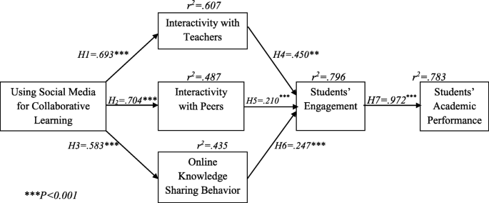

# FUTURE SCOPE

Student engagement in social media and its types represent their physical and mental participation and time spent improving educational excellence, time spent interacting with peers and teachers for collaborative learning. Student engagement is increased when interactions with peers and teachers are in the same direction and ideas are shared. With the advancement in information technology, the virtual world becomes the storehouse of information. In this proposed system, the authentication of the user is done and the user can create his profile to showcase his skills and interests, making it easier for other users to find and connect with them. Also, the user can share their skills and knowledge through various forms of content such as videos, images, and texts. All users can interact with each other through comments, likes, and shares to facilitate community building and learning.

# ACKNOWLEDGEMENT

We would like to take this opportunity to thank all those guideposts who paved the way for us throughout the project leading to the successful and satisfactory completion of this study.

We are very grateful to Prof. Rahul Sonkamble for giving us the opportunity to carry out this project and providing us with all the facilities. I am very grateful to Mr. Sonkamble for his active support, valuable time and advice, sincere cooperation and dedication.

# REFERENCES

1. Akçayır, G. (2017). Why do faculty members use or not use social networking sites for education? *Computers in Human Behavior, 71*, 378–385.
2. Al-Alwan, A. F. (2014). Modeling the relations among parental involvement, school engagement and academic performance of high school students. *International Education Studies, 7*(4), 47–56.
3. Barnes, N. G., & Lescault, A. M. (2011). *Social media adoption soars as higher-ed experiments and reevaluates its use of new communications tools*. North Dartmouth: Center for Marketing Research. University of Massachusetts Dartmouth.
4. Byrne, B. M. (1994). Structural equation modeling with EQS and EQS/windows: basic concepts, applications, and programming. Thousand Oaks: Sage.
5. Cao, Y., Ajjan, H., & Hong, P. (2013). Using social media applications for educational outcomes in college teaching: a structural equation analysis. *British Journal of Educational Technology, 44*(4), 581–593. <https://doi.org/10.1111/bjet.12066>.
6. Chen, I. Y. L., Chen, N.-S., & Kinshuk. (2009). International forum of Educational Technology & Society Examining the factors influencing participants’ knowledge sharing behavior in virtual learning communities published by : International forum of Educational Technology & Society Examining the factor. *Educational Technology & Society, 12*(1), 134–148.